**Hands-on Learning Module – Creating the Cape_Codd database.**

**We are going to work with Microsoft SQL Server Management Studio and create a database called Cape_Codd.mdf. It is a database that stores data regarding outdoor sports.**

**We are going to create the following tables: BUYER, RETAIL_ORDER, SKU_DATA, ORDER_ITEM, WAREHOUSE, INVENTORY, CATALOG_SKU_2016, CATALOG_SKU_2017, CATALOG_SKU_2018.**

**Additionally, we will create a database diagram of the Cape_Codd database tables, as well as populate the tables with the data.**

**Please note that the instructions below are in general form and for more detailed instructions, please review the document attached to the First Set of Assignments – M10A_KROE2749_15_SE_C10A.pdf (starting on page 47).**

**Use the Start Menu and select Microsoft SQL Server Management Studio**

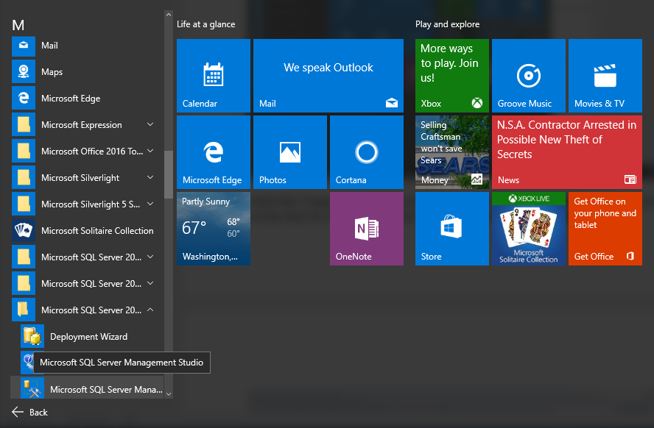

**Click the Connect button to connect to Microsoft SQL Server. Your screen may be slightly different than mine in terms of the Server name.**

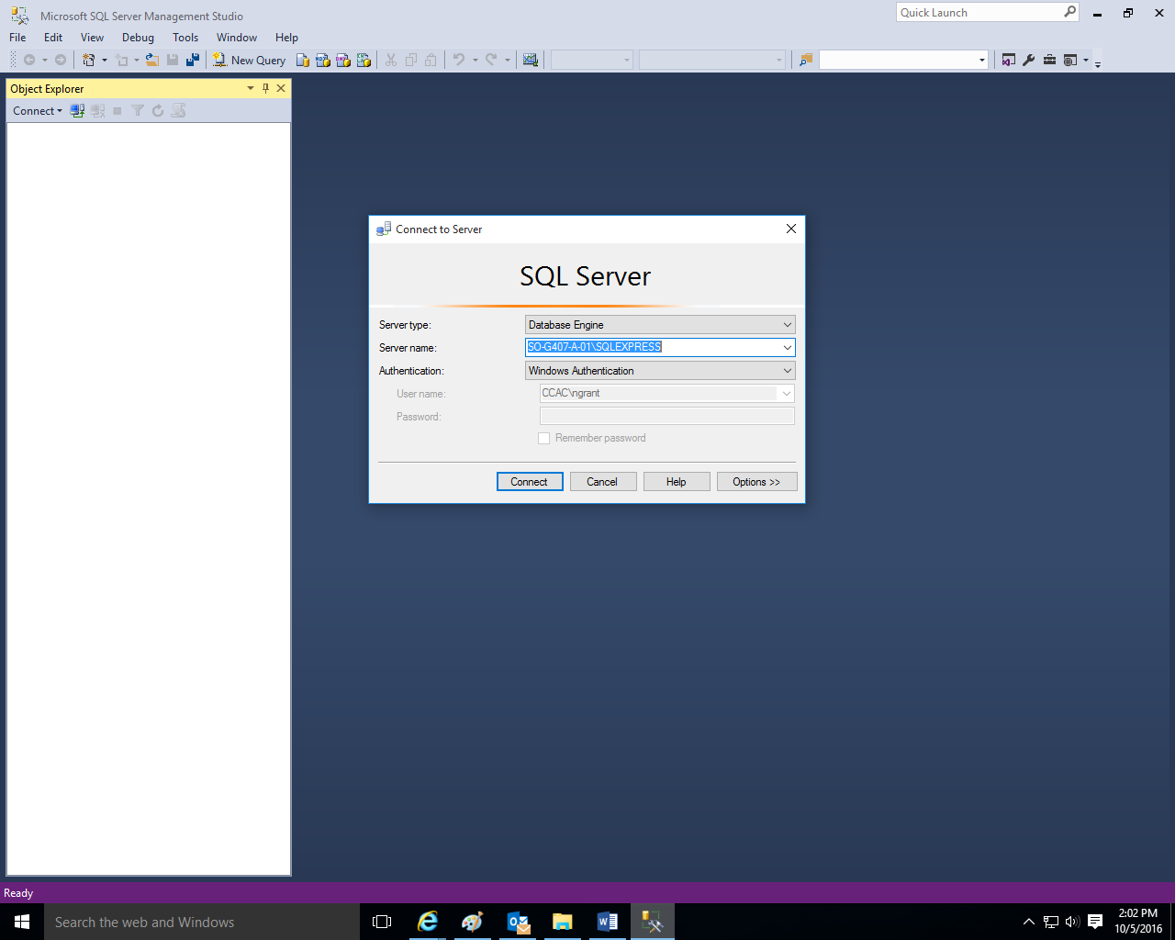

**Right-click on the Databases folder and then left-click on New Database.**

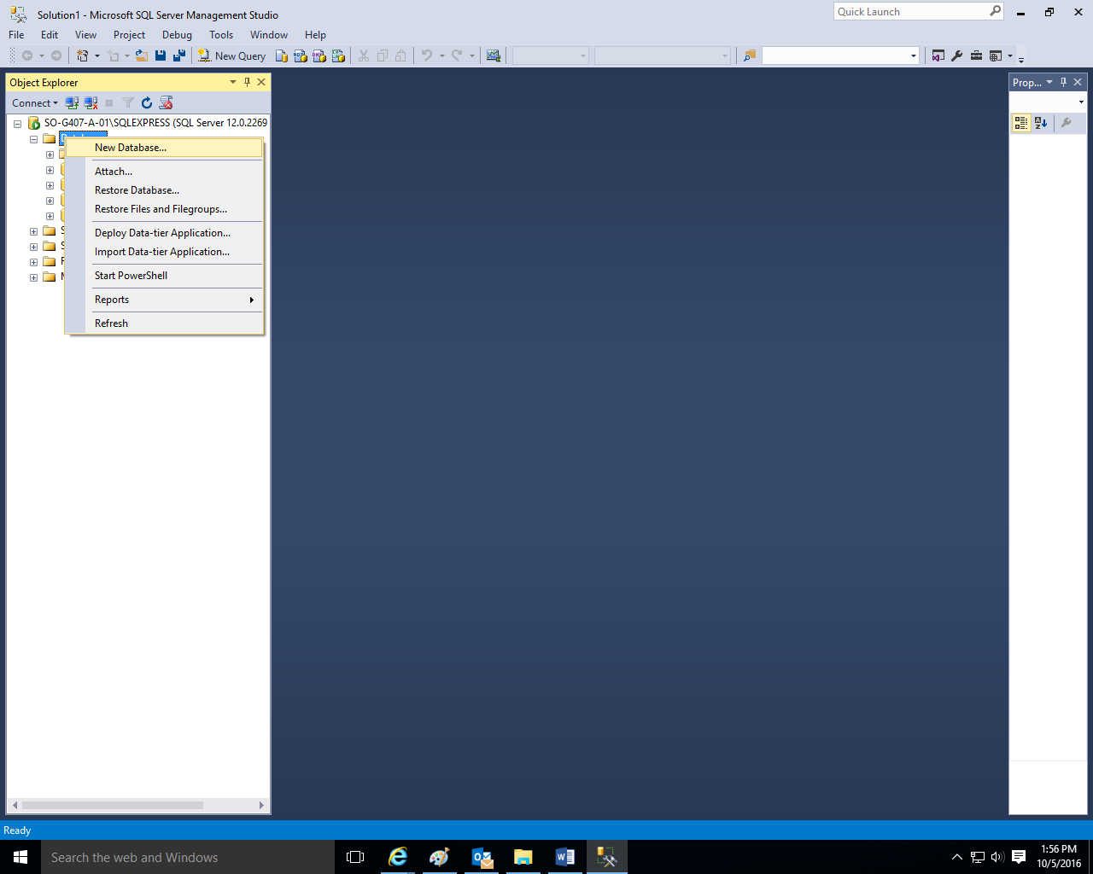

**Type Cape_Codd as the database name and click the OK button.** 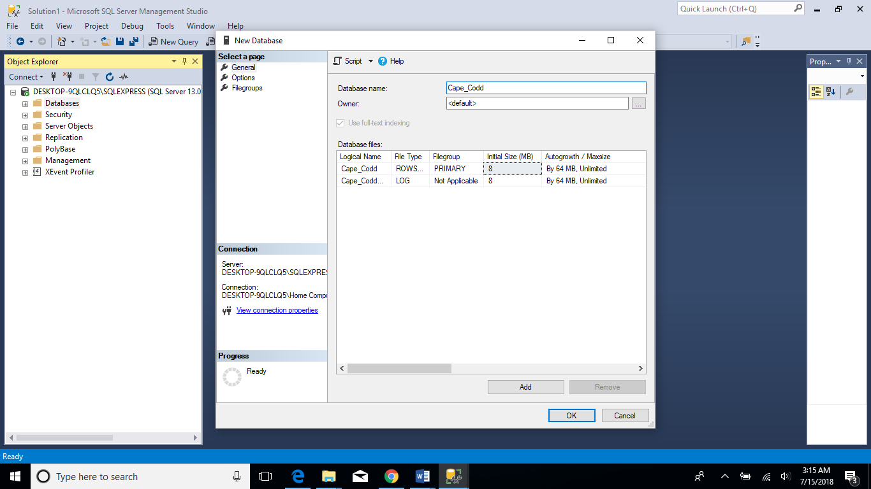

**Once you do this, the system will create your Cape_Codd database with an .mdf extension. It will also create a Cape_Codd.log system file.**

**Click the + sign next to the Databases Folder to view all of the created databases.** 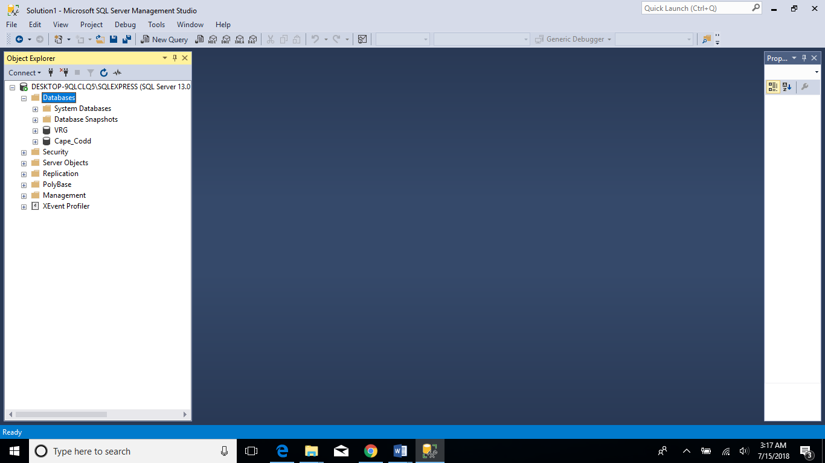

**Click the + sign next to the Cape_Codd database.**

**Download and save the two .sql files (DBP-e15-MSSQL-Cape-Codd-Create-Tables.sql and DBP-e15-MSSQL-CapeCodd-Insert-Data.sql) from the First Set of Assignments at our course at** [**https://courses.ccac.edu**](https://courses.ccac.edu)

**As noted in their filenames, the DBP-e15-MSSQL-Cape-Codd-Create-Tables.sql file will create all of the table structures for the Cape Codd database, and the DBP-e15-MSSQL-Cape-Codd-Insert-Data.sql file will populate the data into the tables.**

**Use the File, Open, File commands and open the DBP-e15-MSSQL-Cape-Codd-Create-Tables.sql file.**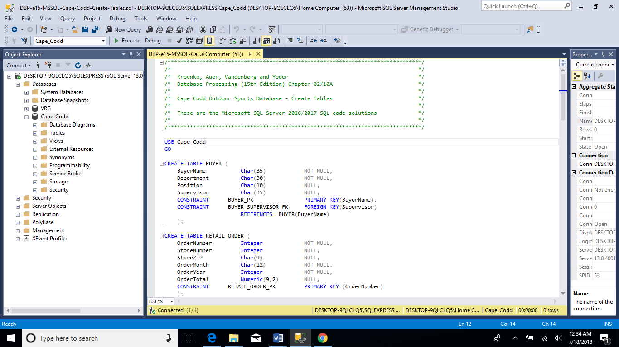

**Click the Execute command to create the table structures.**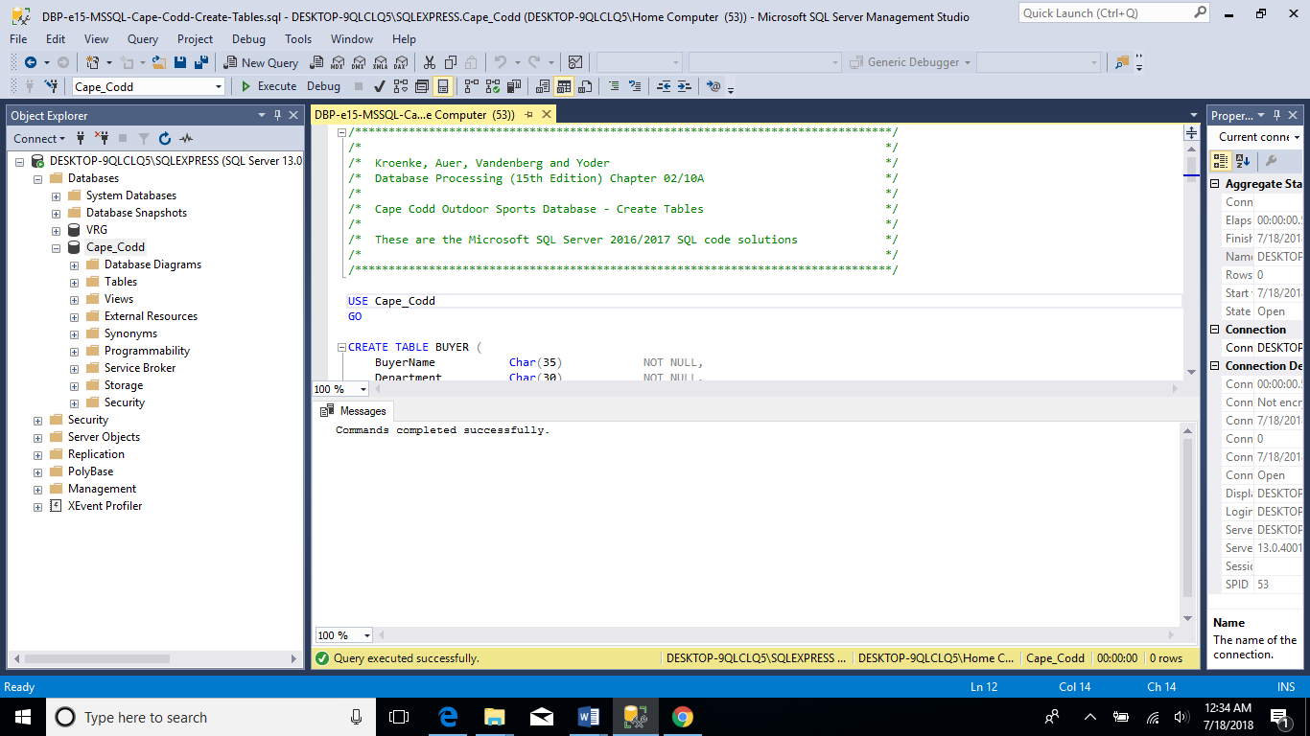

**The system should indicate that the Command(s) completed successfully in the Messages tabbed window.**

**Click the + sign next to the tables folder in order to view the created table structures (dbo.BUYER, dbo.CATALOG_SKU_2016, dbo.CATALOG_SKU_2017, dbo.CATALOG_SKU_2018, dbo.INVENTORY, dbo.ORDER_ITEM, dbo.RETAIL_ORDER, dbo.SKU_DATA, and dbo.WAREHOUSE). dbo stands for database owner.**

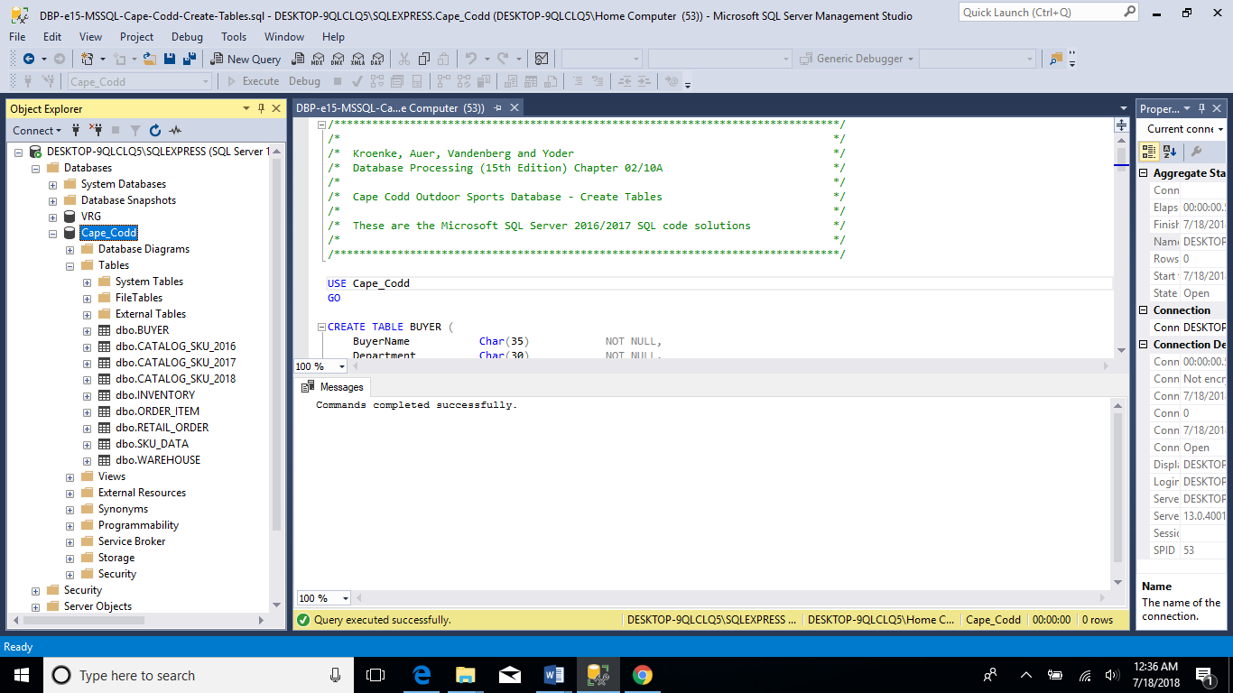

**Right-click on the Database Diagram and then left-click on New Database Diagram.**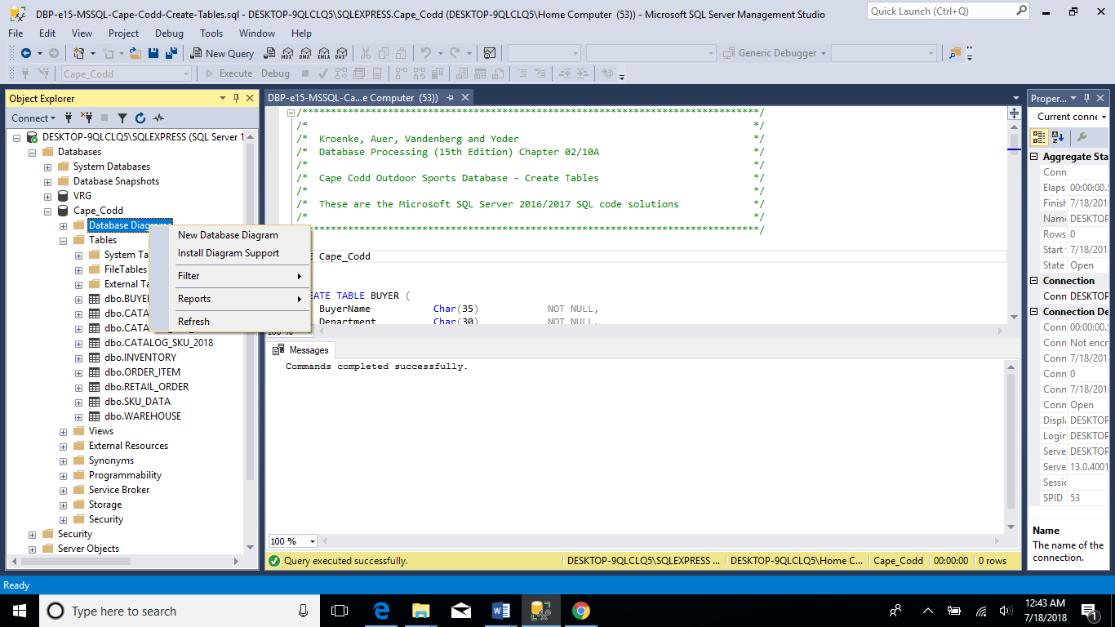

**Click yes to create them.**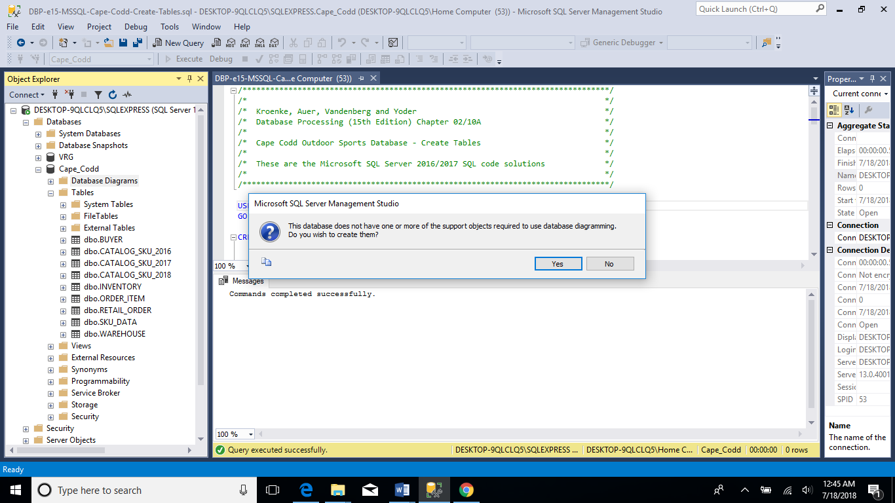

**Click each table and click the Add button to add them to the diagram screen and use the Close button.**

**Create the database diagram as shown below.** 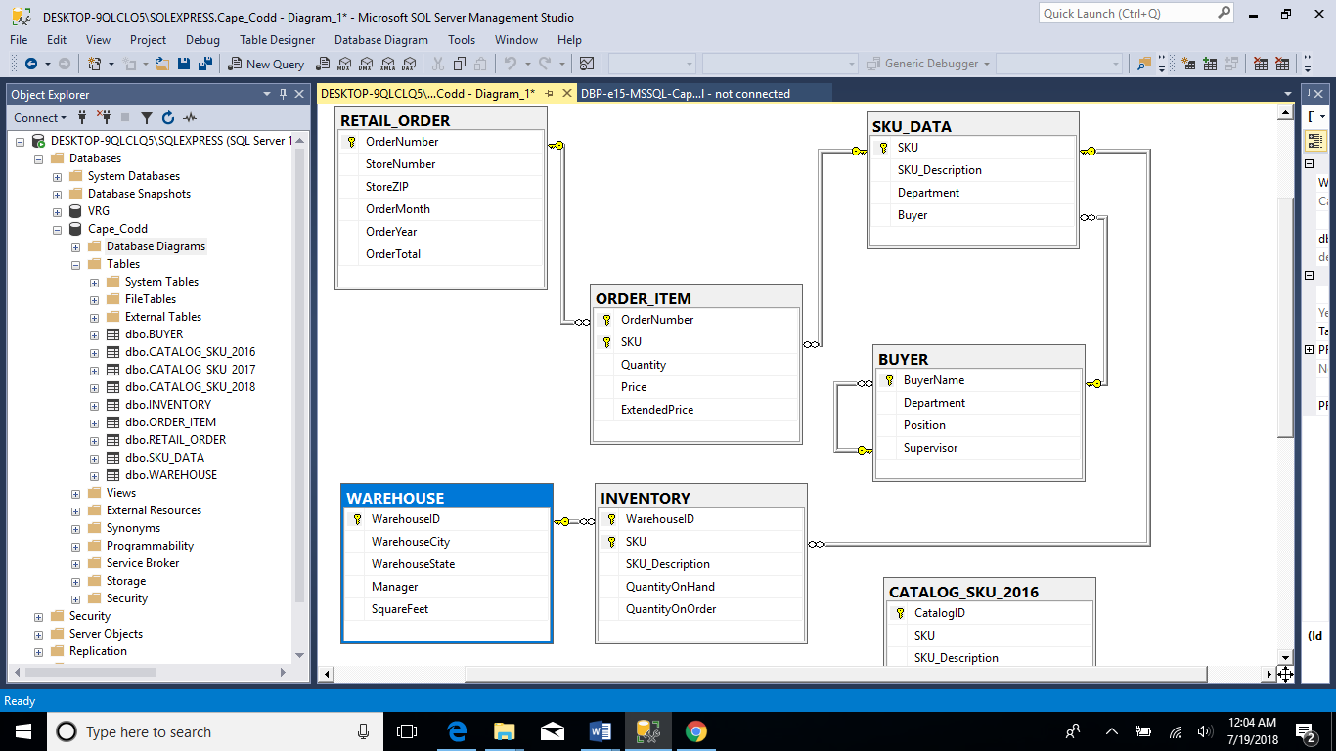

**Click the File, Save Diagram-0 and then save the diagram as Cape_Codd-Database-Diagram and click the OK button to save the diagram.**

**The CATALOG_SKU_2016 table is partially shown in the diagram. The other two tables, CATALOG_SKU_2017 and CATALOG_SKU_2018 are not shown in the diagram but they are directly below the CATALOG_SKU_2016 table.**

**Use the File, Open, File commands and open the DBP-e15-MSSQL-Cape-Codd-Insert-Data.sql file.**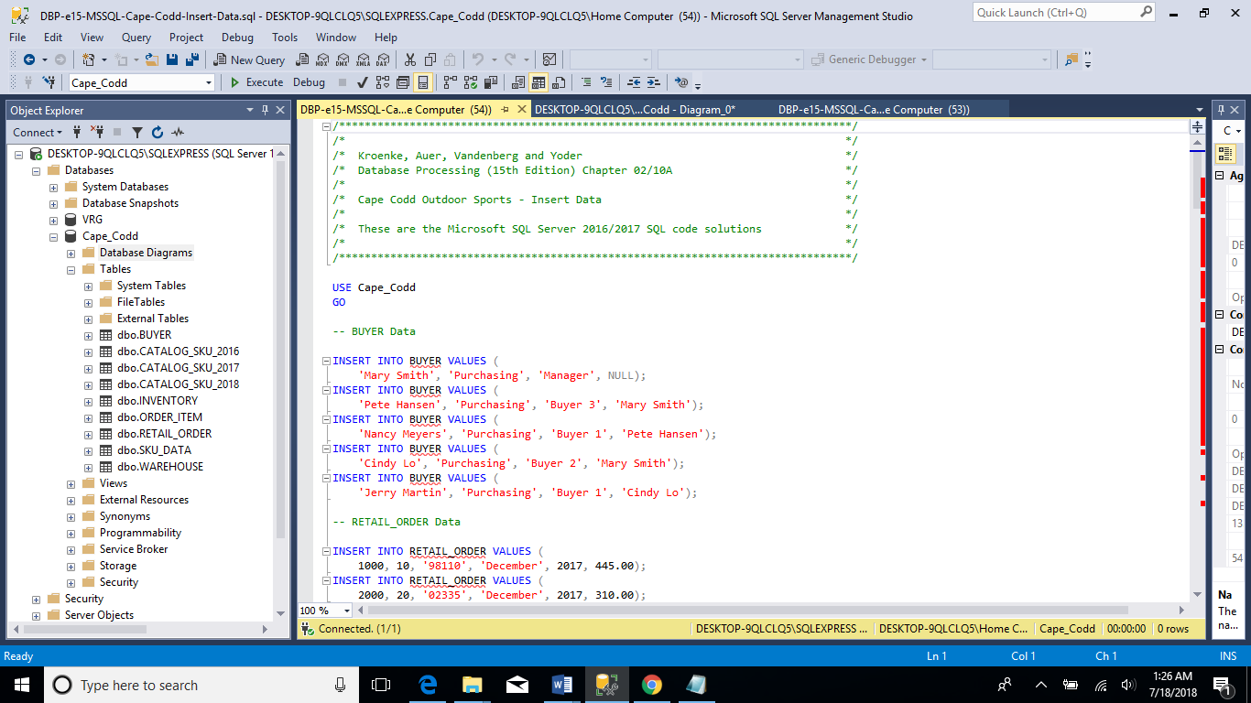

**Click the Execute command to populate or insert the data into the tables.**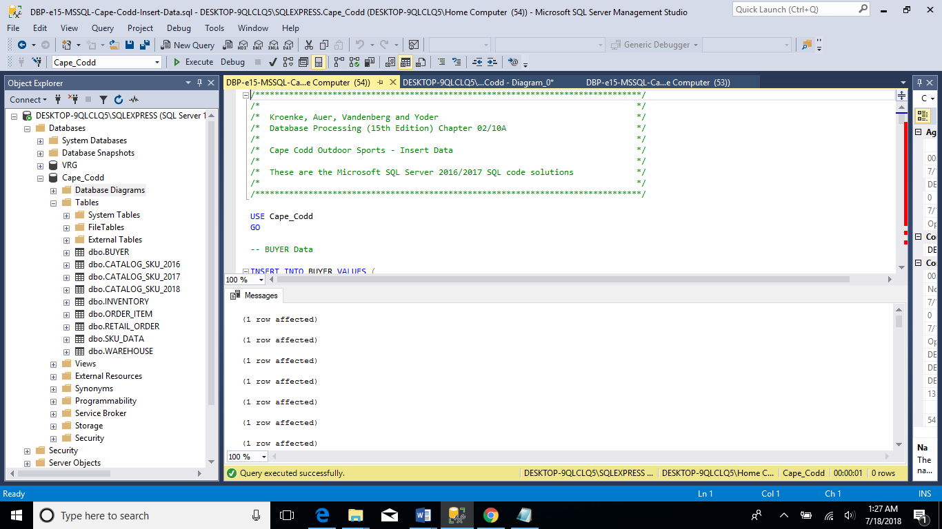

**The system should indicate that the Command(s) completed successfully in the Messages tabbed window.**

**Use the File, New, Query with Current Connection in this case the Cape_Codd database) in order to create some simple queries (from each table).**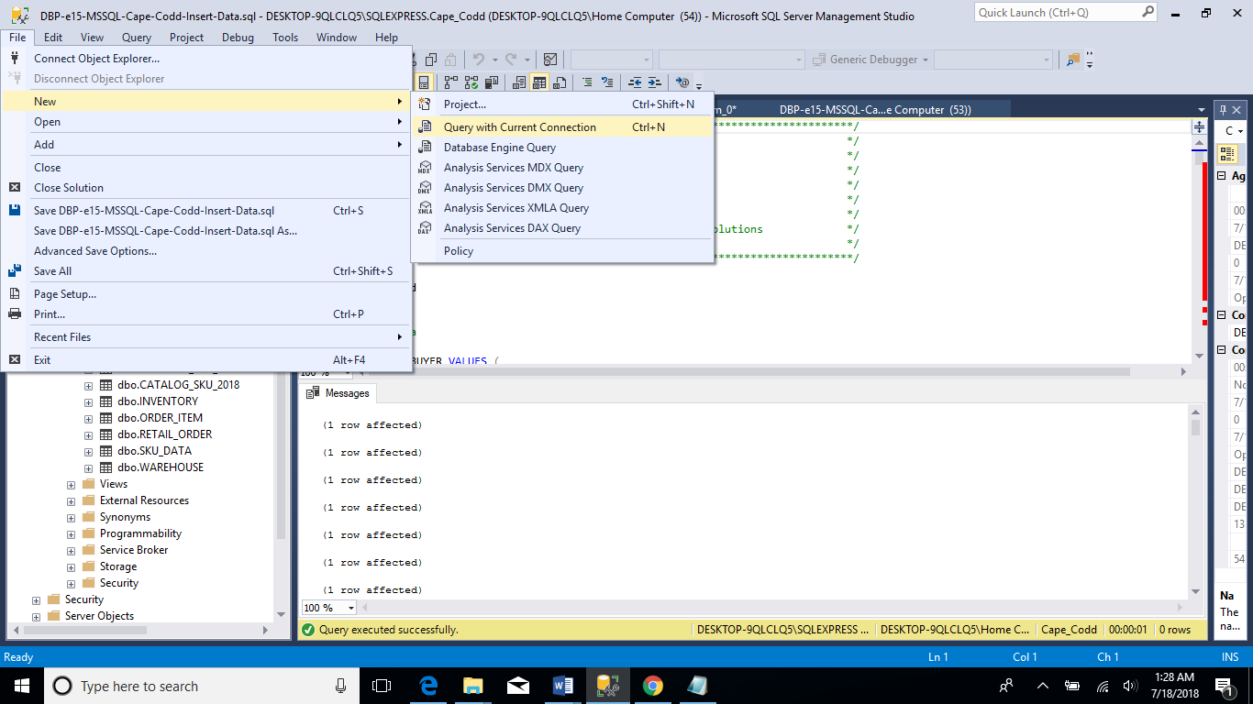

**Type the simple Select queries in order to see the data contained in the BUYER, INVENTORY, ORDER_ITEM, RETAIL_ORDER, SKU_DATA, and WAREHOUSE tables. Highlight the first query and use the Execute button to view the results in the Messages Tabbed Window. Repeat the highlighting process and use the Execute button to review the results of the other queries.**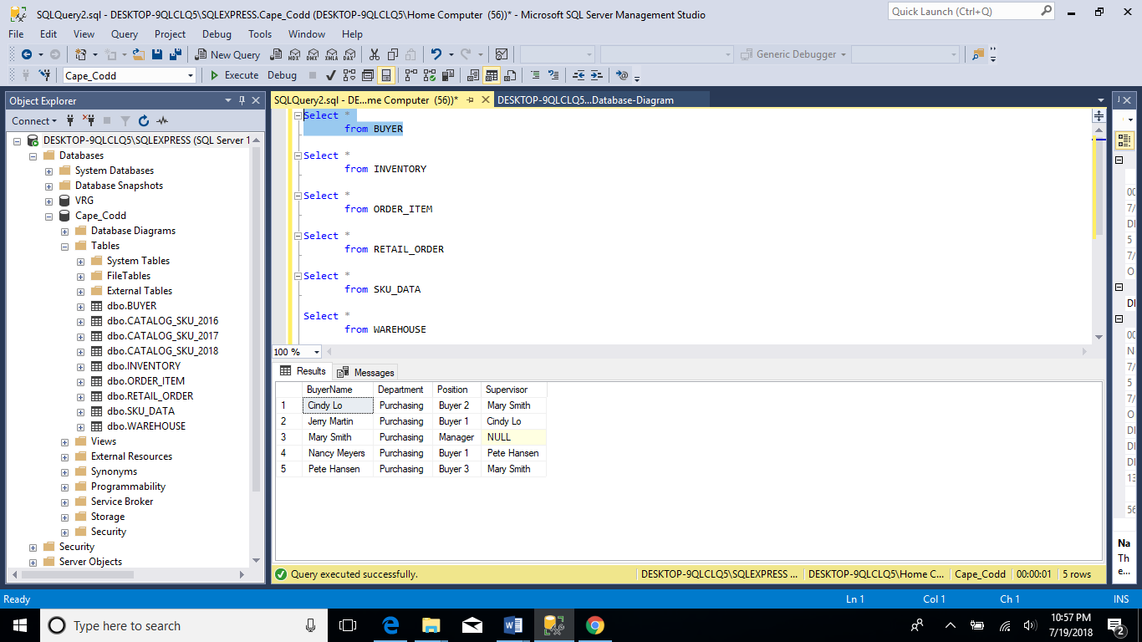

**Use the File, Save As commands and save the query as Cape_Codd Simple Queries.**

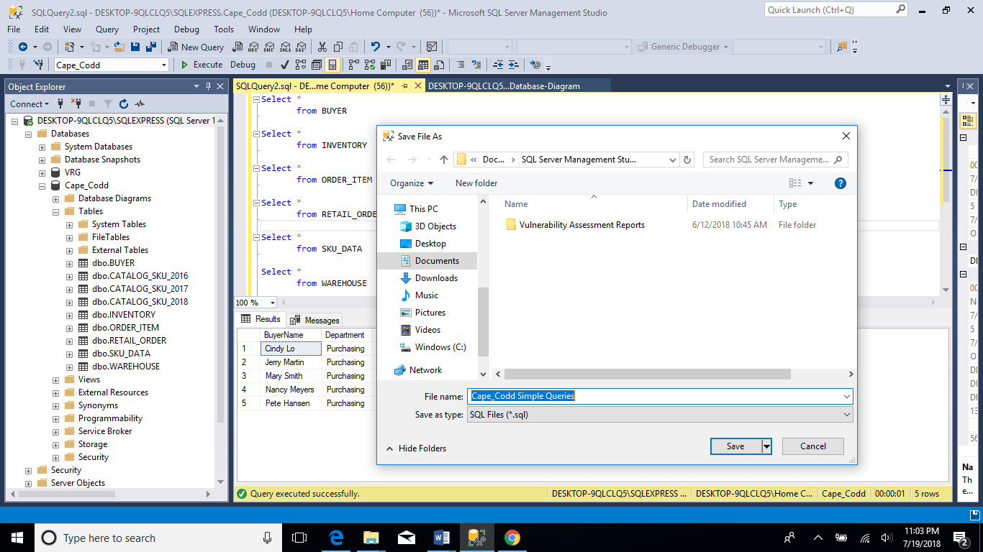

**The software will add a .sql extension to the file.**

**Use the File, Exit commands to exit out of Microsoft SQL Management Studio.**

**As time permits, students may want to research and explore other items such as reviewing relationships in the tables, creating indexes, creating views, backing up and restoring databases, using designer windows, importing data from other Microsoft products, such as Microsoft Excel, using Transact-SQL statements, creating stored procedures, creating triggers, as well as working with database security settings.**